TRIBHUVAN UNIVERSITY
PATAN MULTIPLE CAMPUS
PATANDHOKA, LALITPUR

LAB REPORT
COMPUTER GRAPHICS (BIT 304)

SUBMITTED BY: | SUBMITTED TO:
NAME: SURESH DAHAL | PHUL BABU JHA
CLASS: BIT – III/I
ROLL: 23 | ________________________
DATE: 2082-12-10 | CHECKED BY
- Write a C program for DDA line generation if the user can input the endpoints of the line.

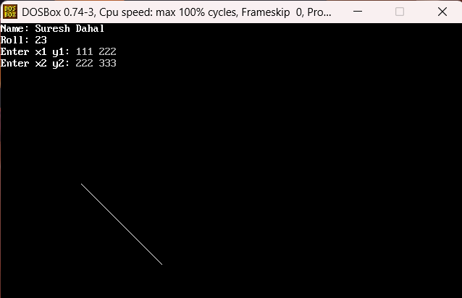
- Write a C program for DDA Line generation of Endpoints A(10,12) and B(15,17)
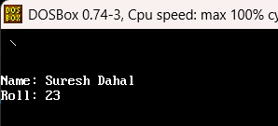
- Write a C program for BSA line generation if the user can input the endpoints of the line
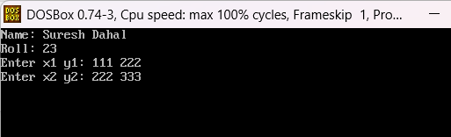

- Write a C program for BSA Line generation of Endpoints A(8,12) and B(18,20)
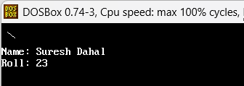
- Write a C program for generating a BSA circle algorithm
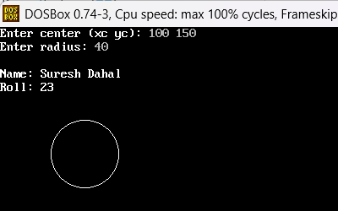
- Write a c program for Generating All points of the Circle by mid-point Algorithm
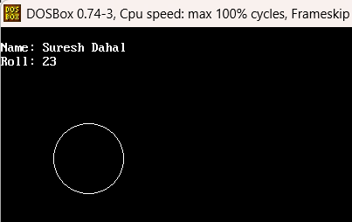
- Write a program to rotate the following shape
  - Rotate line AB whose endpoints are A (2, 5) and B (6, 12) about the origin through a 30° clockwise direction.

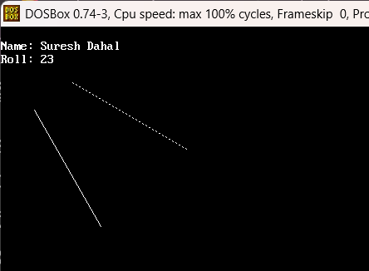

  - Rotate line AB whose endpoints are input by the user about origin through a 30° anticlockwise direction.
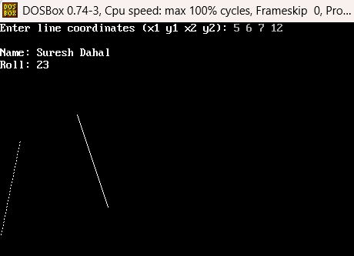
- A triangle ABC is given. The coordinates of A, B, and C are given as A (3 4), B (6 4), and C (4 8) Write a program to reflect the position of the triangle i.e., to the x-axis.
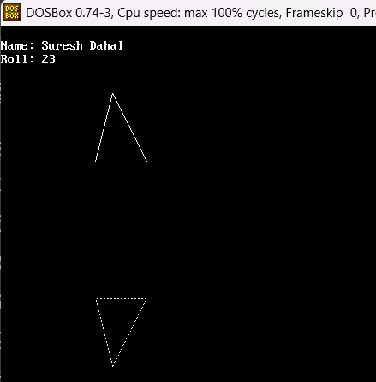
- Write a program to perform the following
  - Translation, rotation, scaling
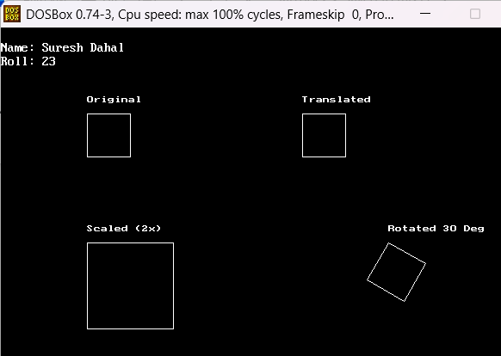
- Write a program to perform Line Clipping using Cohen Sutherland Algorithm user can input line coordinates.
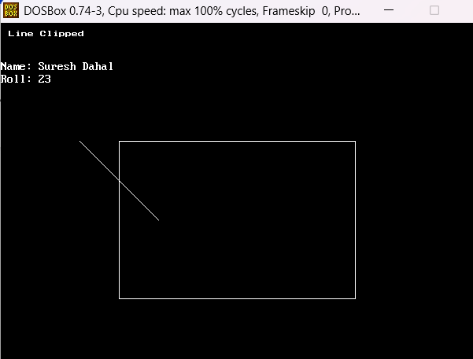
- Program to clip a line using the Liang Barsky Method.
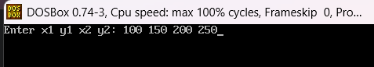
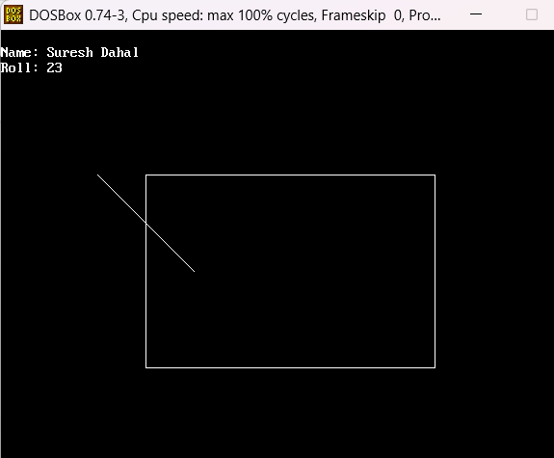

- Program to implement Parallel Projection in 3-Dimensions.
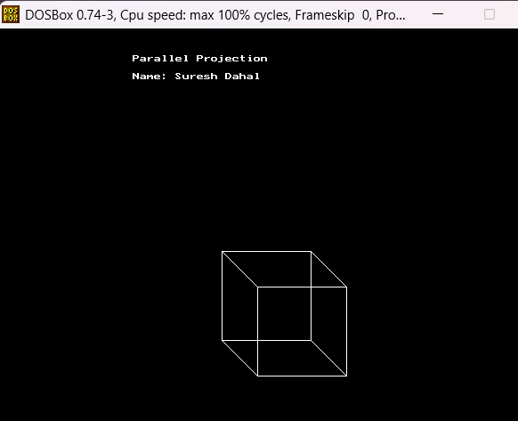\

- Program to implement Standard Perspective Projection in 3-Dimensions.
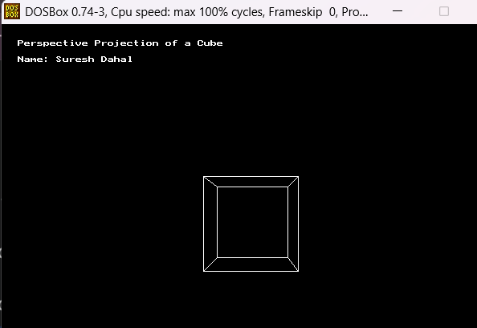
- C program to demonstrate drawing a circle using OpenGL

